# RGB LED analog input potentiometer

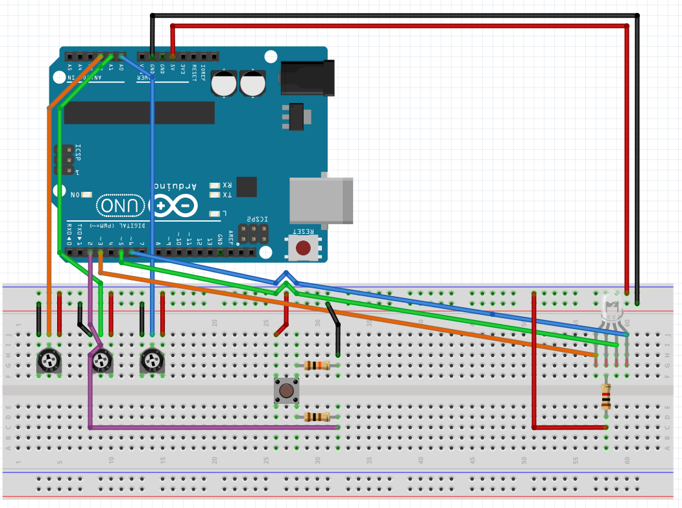

## Parts

Microcontroller: Arduino UNO 1

Breadboard 1

RGB LED 1

Potentiometer 3

Resistor 10k ohm 1

Resistor 1k ohm 1

Resistor 100 ohm 1

Switch 1

Wire 18

## Description

This circuit help user easier to make night club light. User can create color of light by adjust Potentiometers(analog signal 0-1023); which are left Potentiometer controls red color, middle Potentiometer controls green color and right Potentiometer controls blue color. The amount of each color will show on the serial monitor (PWM 0-255). In additional user can bling the light by hold on the switch button.

## Sketch

https://github.com/ravenncrows/Arduino.git